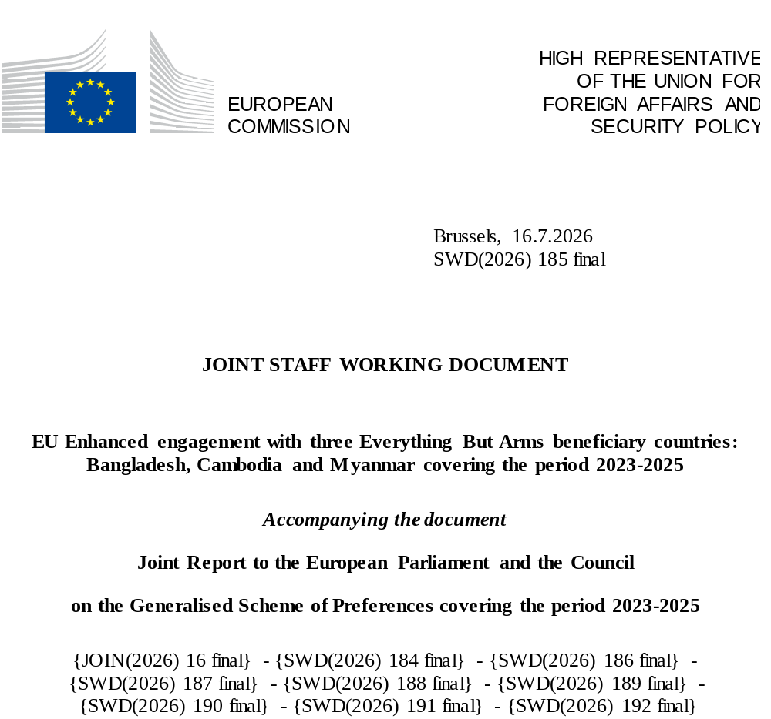

- Introduction

This is the third joint Staff Working Document (SWD) dedicated to the Enhanced Engagement with three GSP beneficiary countries: Bangladesh, Cambodia and Myanmar. Enhanced Engagement with these countries started under the Everything But Arms (EBA) arrangement of the EU’s Generalised System of Preferences (GSP) in 2017. So far, no other beneficiaries have been subjected to this targeted process.

The present document covers the main developments during the reporting period of 2023 to 2025 on core human rights and labour rights international conventions that were discussed with each of the three EBA beneficiary countries under Enhanced Engagement. Relevant economic data are available under section 4c of the GSP report.

- Bangladesh

The political landscape in Bangladesh at the start of the reporting period was marked by heightened polarisation and tensions between the ruling party and opposition forces, which eventually led to the fall of the government that had been in power for 15 years. As from August 2024, the country was governed by an interim administration led by Chief Adviser Muhammad Yunus which prepared the path to genuinely competitive parliamentary elections and a referendum which took place in a peaceful atmosphere on 12 February 2026. The new government was sworn in on 17 February 2026, in a smooth transfer of power.

The EU regularly informed Bangladesh of its concerns regarding the compliance with EBA requirements. In November 2023, the Commission and the European External Action Service (EEAS) had also conducted a monitoring mission to assess the compliance of the country with its commitments under the EBA. The enhanced engagement process under the Yunus administration allowed for constructive bilateral exchanges both on human and labour rights.

On human rights, several positive developments were noted. Bangladesh ratified the Optional Protocol to the Convention against Torture (OP-CAT) in 2025, strengthening the formal framework for torture prevention through independent visits and a National Preventive Mechanism requirement. The interim government withdrew Bangladesh’s long-standing reservation against CAT Article 14(1) as from 3 February 2026, enabling individual communications and aligning with long-standing international recommendations. A Convention on the Elimination of All Forms of Discrimination against Women (CEDAW) periodic report was eventually submitted in 2025, restoring a key reporting channel even though concluding observations are still pending. Legislative initiatives include the Women and Children Repression Prevention (Amendment) Ordinance (2025). In August 2024 the interim government acceded to the International Convention for the Protection of All Persons from Enforced Disappearance (ICPED).

Several challenges remain, however. The Office of the High Commissioner for Human Rights (OHCHR) documented extensive violations during the unrest of July/August 2024, including large-scale unlawful killings, arbitrary arrests, torture/ill-treatment, attacks on journalists, and internet shutdowns, indicating severe International Covenant on Civil and Political Rights (ICCPR) and CAT implementation failure. The Cyber Security Act (2023) is widely assessed as retaining core flaws of prior legislation and continues to threaten the freedom of expression, with reported misuse against journalists and human rights defenders. Under concerns relevant for the International Convention on the Elimination of All Forms of Racial Discrimination (ICERD), Committee on the Elimination of Racial Discrimination (CERD)’s Early Warning and Urgent Action engagement on the Chittagong Hill Tracts remains open, reflecting unresolved issues on discrimination, militarisation impacts, and indigenous land and participation rights. Reservations on the CEDAW remain in place and legal gaps on sexual violence -including the restrictive scope of marital rape provisions- continue to impede gender-equality compliance.

With respect to labour rights, the Government periodically made public the implementation reports of the National Action Plan (NAP) on the Labour Sector 2021-2026. In parallel the Government has been reporting under the International Labour Organisation (ILO) Article 26 mechanism on the implementation of the Roadmap on the Labour Sector in Bangladesh (2021-2026), which is mutually reinforcing with the NAP. In March 2026, the ILO Governing Body requested the Government to report on further progress made in the implementation of the Roadmap at its 359th Session in March 2027, and deferred its decision on further action until that session. In 2025 the Government issued an Ordinance (then adopted into law in April 2026) amending the Bangladesh Labour Act (BLA), a comprehensive review that introduces changes in a number of areas (amendments in relation to Freedom of Association and other fundamental principles and rights at work, for example on ease of trade union registration, including by modifying minimum membership requirements, allowing collective bargaining at a higher level, and additional powers for labour inspectors as well as reinforcing critical protections by prohibiting discrimination) for which the ILO Committee of Experts on the Application of Conventions (CEACR) had been requesting better alignment with ILO international labour standards. While the local ILO Office has been supporting the Government on a technical level in relation to the BLA reform, the extent to which additional April 2026 amendments align with the conventions is yet to be assessed by the CEACR. Regarding child labour, the list of hazardous work prohibited to children has been updated, with five new sectors included. Bangladesh’s recent ratifications of ILO Occupational Safety and Health Convention, 1981 (No. 155), ILO Promotional Framework for Occupational Safety and Health Convention, 2006 (No. 187), and ILO Violence and Harassment Convention, 2019 (No. 190) in 2025, have been important positive steps, which will need to be followed by effective implementation including by tackling underlying systemic obstacles and corruption.
Significant efforts, however, are still needed to meet the country’s obligations and translate labour commitments into measurable outcomes, particularly on Export Processing Zone (EPZ) rights, union registration/anti-union discrimination, inspection coverage and quality (including forced labour indicators), gaps in implementing occupational health and safety, and reductions in child labour in informal and hazardous work. Despite some progress, important restrictions persist on freedom of association and on registration of trade unions. Various pieces of legislation, including the penal code, foresee imprisonment with the possibility of forced labour. A significant number of children are still involved in hazardous work. The Government needs to continue strengthening the capacities of the law enforcement bodies with regard to child labour and ensure that dissuasive penalties are imposed.

- Cambodia

Over the reporting period, key exchanges took place at the 12th EU–Cambodia Joint Committee in Brussels on 25 April 2024 and related sub-group meetings. Political contacts intensified, with several high-level meetings with Prime Minister Hun Manet. Further exchanges took place at the 13th EU–Cambodia Joint Committee in Phnom Penh and related sub-group meetings in March 2026.
For the current reporting period, the priorities remained broadly the same as for the previous reporting period (2020-2022) and as shaped by international monitoring bodies: reopening civic and political space; ending the criminalisation of opposition figures, activists, trade unionists and independent media; reforming restrictive laws; strengthening judicial independence and accountability for arbitrary detention, torture and other ill-treatment; addressing anti-union discrimination and misuse of criminal law in labour disputes; protecting indigenous peoples’ land rights and ensuring free, prior and informed consent; adopting a comprehensive anti-discrimination framework; reforming domestic violence legislation and improving protection of women and human rights defenders; criminalising torture in line with convention; and adopting a compliant Child Protection Law.

On human rights, Cambodia has maintained formal adherence to the core UN human rights treaties and has introduced some plans and policy frameworks, particularly in relation to social protection, violence against women, alternative care for children, and the possible creation of anti-torture mechanisms. Initiatives such as the Decent Work Country Program (DWCP) 2024-2028 and the National Strategy for the Development of the Informal Economy 2023-2028 represent tangible progress in economic and social rights, especially for guaranteeing the right to work to vulnerable sectors of the informal economy.
However, critical gaps remain. Political freedoms in Cambodia have continued to be severely curtailed. There has been no improvement in relation to political freedoms, and the democratic space is closing even more. The opposition Candlelight Party (CLP) continues to be barred from national elections (2023), resulting in a fully Cambodian People's Party (CPP) dominated National Assembly. Judicial harassment of opposition figures continues. Former opposition leader Kem Sokha, convicted of treason and held under strict house arrest for eight years, was granted a royal pardon on 26 May 2026. However, the charges against him were not dropped and restrictions on his political participation and his ability to leave the country remain in place. Other figures have also been jailed on trumped-up charges (for instance Nation Power Party leader Sun Chanthy). The bill to create a National Human Rights Institution (NHRI) has been pending for approval since the end of 2023. The rights of indigenous peoples face excessive delays in the attribution of land ownership, and the Environment and Natural Resources Code, in force since 2025, is exclusionary in that it restricts traditional practices and facilitates evictions. The 1996 Nationality Law, amended in 2025, introduces the possibility of revoking citizenship from any national, including women and minors, on grounds such as ‘treason’ or ‘collusion with foreign powers’ increasing the risk of statelessness. Very high levels of violence against women continue.
Severe restrictions on freedom of expression and association remain in place under regulations such as the Criminal Code and the Law on Associations and November 2025 decree on ‘Qualifications and Professional Journalism’. The last independent media, Voice of democracy (VOD), was forced to close in 2023 and is not operational in Cambodia at the time of writing of this report. Preventive detention is used indiscriminately. The lack of independence of judges and courts is consolidated as a political tool. The authorities continue to rely extensively on ‘incitement’ and ‘plotting’ charges against students, environmental defenders, trade unionists and independent media actors, creating a chilling effect across civil society. Disparities in equitable access to health, education, and basic services persist, especially in rural areas. An increasing number of human trafficking cases have been reported linked to the activities of scam centres operating on the Cambodian territory.
On labour rights, Cambodia undertook some policy initiatives, such as the Cambodia Decent Work Country Programme 2024-2028, in cooperation with ILO, and the National Strategy on Development of the Informal Economy 2023-2028; and training activities such as vocational education training and safety in agriculture practices with ILO support. The National Social Security Fund now benefits 2.5 million workers, including informal and self-employed, with coverage for injury, health and pensions. Cambodia is working on judicial and legal reforms which will impact labour rights such as the Personal Data Protection Law (PDPL).
However, these steps are not matched by effective implementation measures which remain slow and weak. Serious concerns remain regarding forced labour particularly in scam operations and in the fisheries sector; child labour, including in its worst forms, such as sexual exploitation, violations of freedom of association and collective bargaining, impunity regarding attacks against trade unionists, including unresolved homicides, restriction of strikes, which perpetuates a climate of fear, discrimination and repression of trade unionists. The situation reveals inadequate protection of human rights defenders, trade unionists and workers against acts of violence, discrimination, and persistent gender inequality. Disparities also persist regarding opportunities for indigenous women and women from ethnic minorities to access work and justice. Significant gender inequalities continue with particular implications for women who face intersecting forms of discrimination, such as indigenous and ethnic minority women, those with disabilities, LGBTIQ+ persons or living in rural areas .
Cambodia's preferential access to the EU market remains restricted after GSP preferences were partially withdrawn in 2020 because the government failed to address the EU's human rights concerns. The socioeconomic impact of the withdrawal, including the impact on workers, was taken into account when selecting the products and deciding the scope of the withdrawal. Cambodia continues to benefit from the preferences for those tariff lines not covered by withdrawal. This targeted approach is complementing the continuous EU efforts towards poverty reduction in the country.

- Myanmar

Five years on from the 2021 military coup, condemned by the EU, Myanmar remains affected by protracted armed conflict and a severe humanitarian crisis. Grave human rights violations persist, including arbitrary arrests and detentions, airstrikes on civilians, and widespread displacement. The EU has repeatedly condemned these violations, including the atrocities against the Rohingya and other minorities, as well as the continued restrictions on fundamental freedoms and the prevailing climate of fear. The EU has also stated that the electoral process carried out by the military regime in December 2025 and January 2026, was neither free, fair nor inclusive, failing to meet basic international standards. The humanitarian situation remains critical, with over 16 million people estimated to be in urgent need of assistance. As the largest donor responding to the crisis, the EU and its Member States remain committed to finding effective ways to deliver much needed assistance to those affected.
In response to the military coup, the EU has adopted successive rounds of restrictive measures against individuals and entities associated with the military regime and its economic interests and stands ready to adopt further measures against those responsible for ongoing violence, serious human rights violations and transnational crime. At the same time, the EU has sought to ensure that its response remains proportionate and avoids unintended adverse effects on the civilian population, in line with the ’do no harm’ principle. EU measures have been designed to remain targeted, while preserving economic activity that supports livelihoods. This calibrated approach has informed the EU’s continued engagement with Myanmar under the EBA. While the EU has refrained from any formal engagement or direct contacts with the regime, the enhanced engagement process was maintained during the reporting period through exchanges with economic operators, civil society organisations, and democratic stakeholders.
The priority areas for enhanced engagement remain focused on supporting restoration of democratic processes and civilian rule; responding to setbacks in women and children’s rights and economic, social, and cultural rights; addressing systematic forced labour and violations of freedom of association; ensuring unimpeded delivery of aid to populations affected by conflict.

By maintaining the EBA preferences, the EU aims to ensure that the pursuit of the poverty reduction goal continues at a time of a severe humanitarian crisis in Myanmar. This is particularly relevant in labour-intensive sectors such as garments, which provide employment to a significant share of the workforce, notably women and internal migrants, who otherwise could have found themselves outside the formal labour market. Against the backdrop of the acute humanitarian crisis, any adverse impact on the livelihoods of the civilian population, in particular vulnerable groups, as a consequence of a potential withdrawal of EBA preferences, should be avoided. The EBA also allows the EU to preserve leverage and sustain a responsible economic footprint in Myanmar. Economic operators linked to EU supply chains, subject to enhanced due diligence requirements, continue to contribute to comparatively higher labour and social standards than their competitors.

The EU continues to regularly reassess its policy on EBA engagement with Myanmar, taking into account developments on the ground as well as relevant international processes. These include, inter alia, the 2025 resolution adopted under Article 33 of the ILO Constitution and the ongoing proceedings before the International Court of Justice concerning the application of the Convention on the Prevention and Punishment of the Crime of Genocide. With regards to the labour rights situation the findings and recommendations of the ILO’s Commission of Inquiry remain the basis of our assessment. The EU continues to support the full implementation of the Article 33 resolution and underline the importance of continued follow-up by all ILO constituents. The EU remains prepared to adapt its approach towards Myanmar under the GSP, as appropriate, in line with evolving circumstances and its overarching objective of supporting the people of Myanmar.

- Development cooperation in support of EBA objectives

EU development cooperation with Bangladesh and with Cambodia is implemented through Neighbourhood, Development and International Cooperation Instrument (NDICI)—Global Europe and in line with Global Gateway. The cooperation with Myanmar takes into account the specificity of the country’s situation, in compliance with the Foreign Affairs Council Conclusions of February 2021.
Bangladesh
Through the Global Gateway strategy, the EU and Bangladesh work together to promote Clean Energy and Climate Action, education, Technical and Vocational Education and Training and skills, inclusive governance, migration management, and resilience. The Multiannual Indicative Programme (MIP) for Bangladesh with the allocation for 2021-2027 of EUR 470 million supports three priorities: 1) Human Capital Development, 2) Green Inclusive Development, and 3) Inclusive Governance. Under the European Fund for Sustainable Development Plus (EFSD+) the EU has also made investments in Bangladesh’s energy, railway and water sectors. Further investments are planned to support the country’s green energy transition and circular economy. The country also benefits from two Team Europe Initiatives (TEIs) covering Decent Work and Green Energy Transition as well as several regional programmes, including in the areas of disaster risk responsiveness and energy connectivity.
Bangladesh is also an EU priority country for migration. EU support of more than EUR 92 million includes the reintegration of returnees, support to the Talent Partnership between EU and Bangladesh (legal migration) and building Rohingya refugees’ and host communities’ resilience. An action on integrated border management is planned.
Several interventions are particularly relevant for the EBA Enhanced Engagement. ’Advancing decent work’ and ’Support to the National Social Security Strategy Reforms’ support social protection, labour reforms and enabling environment for labour rights. ’Promoting Justice for All: For a more inclusive and effective justice system in Bangladesh’ promotes rule of law and human rights in Bangladesh.
Cambodia
The EU is engaging with Cambodia on the necessary reforms to achieve the SDGs and to fulfil the conditions necessary for a possible reinstatement of full EBA preferences.
The 2021-2027 Multiannual Indicative Programme for Cambodia (EUR 235 million) supports three priorities: 1) green growth and decent jobs; 2) education and skills development; 3) good governance – fully aligned with Cambodia’s Pentagonal Strategy Phase 1 and the EU Indo-Pacific Strategy. This cooperation follows a human-rights-based approach and is aligned with core United Nations (UN) and ILO conventions relevant for the GSP. It is therefore key to address gaps in the effective implementation and safeguard of human rights and labour rights in the country.
EU’s support is contributing to Cambodia’s integration in Association of South East Asian Nations (ASEAN), as well as to the strengthening of value chains, trade facilitation, competitiveness, and compliance with international standards. The EU Global Access and Trade Expertise (EU GATE) programme contributes to improving regulatory measures and practices in Cambodia in support of inclusive and sustainable exports to the EU and regional markets, with a focus on the cashew nut and pepper value chains as well as on the Garment, Footwear and Travel Goods sector. The EU-Cambodia Partnership for Sustainable Agriculture and Food Systems and the Partnership for Sustainable Energy Practices in Industry programmes are also key to providing support to these crucial value chains and improve competitiveness, environmental sustainability, and better working conditions. Moreover, the Global Gateway flagship Partnership in Education for Green and Digital Jobs supports Cambodia’s industrial growth and transition to an upper-middle-income country by providing young Cambodians, particularly women and girls, with the skills necessary for future employment in green and digital sectors. Notably, the EU supports the promotion and protection of the civic space in Cambodia and the inclusive participation of the civil society. EU-funded initiatives support Civil Society Organisations addressing a broad range of human rights issues, including freedom of expression, labour rights, and democracy, and they contribute to empowering vulnerable and marginalised groups by supporting their engagement in policymaking and electoral processes.
Myanmar
EU cooperation in Myanmar is guided by the Foreign Affairs Council Conclusions of February 2021, adopted after the military coup. Accordingly, the EU suspended all activities that might be perceived as supporting or legitimising the military authorities. After a careful review of the development assistance portfolio, the EU, in consultation with its Member States, adopted a ‘back to basics’ approach. This approach focuses on providing direct support to the people of Myanmar, particularly the most vulnerable communities, to help build their resilience in collaboration with civil society actors, Non-Governmental Organisations (NGOs), and international organisations. The 2021-2027 bilateral development assistance benefitting the people of Myanmar (~EUR 290 million) is strategically organised around three main sectoral priority areas: (1) Peace and governance, (2) Education, (3) Sustainable livelihoods and green growth. The people of Myanmar also benefit from additional humanitarian funds as well as regional and thematic programmes.
EU support, particularly in the area of sustainable livelihoods and green growth, aims at reducing poverty and strengthening the resilience of Myanmar’s most vulnerable populations. Promoting economic resilience is at the core of several EU interventions that encourage responsible business practices, improve working conditions, safeguard decent jobs, and expand access to skills development and employability opportunities.
These initiatives aim not only to reinforce economic resilience but also to ensure that economic activity aligns with social and environmental standards. EU programmes in this sector are designed to support compliance with relevant EU legislation on corporate sustainability, including the Corporate Sustainability Due Diligence Directive (CSDDD), the Corporate Sustainability Reporting Directive (CSRD), and the Forced Labour Regulation (FLR).

Roadmap of actions to address all the outstanding issues mentioned in the complaint concerning non-observance by Bangladesh of the Labour Inspection Convention, 1947 (No. 81), Freedom of Association and Protection of the Right to Organise Convention, 1948 (No. 87).
For years 2020-2022 see the dedicated SWD(2023) 360 final of 21.11.2023
Key events in 2026 at the moment of writing have been included in this Staff Working Document. All links provided were up to date as of 28 April 2026.
JOIN(2026) 16.
Statement by the Spokesperson for EU Foreign Affairs and Security Policy on the elections: https://www.eeas.europa.eu/eeas/bangladesh-statement-spokesperson-elections_en
Key exchanges took place on the 11th EU-Bangladesh Joint Commission meeting held in Dhaka on 31 October 2024, preceded by a meeting of the Sub-group on Good Governance and Human Rights.
The most recent being the 8th Implementation Status of the NAP in October 2025.
SWD (2023)360 final of 21.11.2023
https://www.ilo.org/publications/cambodia-decent-work-country-programme-2024-2028
https://cdn.misti.gov.kh/documents/202502051007038bjzgpqRQ7Gj.pdf
https://worldpopulationreview.com/country-rankings/global-slavery-index-by-country
CEACR, 114th Session, 2026 noted deep concerns about: (1) the high level of sexual exploitation of children, including through online sexual abuse material and in the context of prostitution, and the so-called ’sale of virginity’ and United Nations. (2024). Summary of stakeholders' submissions on Cambodia. Human Rights Council, Working Group on the Universal Periodic Review, Forty-sixth session, 29 April-10 May 2024 (GE.24-03361(E)), para. 70.
International Labour Organisation (ILO), Observation (CEACR), adopted 2024, published 113rd ILC session, 2025. https://normlex.ilo.org/dyn/nrmlx_en/f?p=1000:13100:0::NO:13100:P13100_COMMENT_ID,P13100_COUNTRY_ID:4417591,103055
See: https://iwgia.org/en/cambodia/4648-iw-2022-cambodia.html
See: https://cambodia.un.org/en/174010-gender-equality-deep-dive-cambodia#:~:text=The%20objective%20of%20this%20%E2%80%9Cdeep,hindering%20inclusive%20and%20sustainable%20development .
Commission Delegated Regulation (EU) 2020/550 of 12 February 2020.
Report of the Commission of Inquiry, Towards Freedom and Dignity in Myanmar, Report of the Commission of Inquiry established in accordance with article 26 of the ILO Constitution concerning non-observance by Myanmar of the ILO Convention concerning Freedom of Association and Protection of the Right to Organise, No 87 (1948), and the ILO Convention concerning Forced or Compulsory Labour, No 29 (1930), 4 October 2023.
International Labour Conference – 113th Session, Geneva, 2025, Resolution concerning the measures recommended by the Governing Body under Article 33 of the ILO Constitution on the subject of Myanmar, 5 June 2025.
https://data.consilium.europa.eu/doc/document/ST-6287-2021-INIT/en/pdf

